Icon can be created using Adobe XD

Use Mac App

Assest Catalog Creator

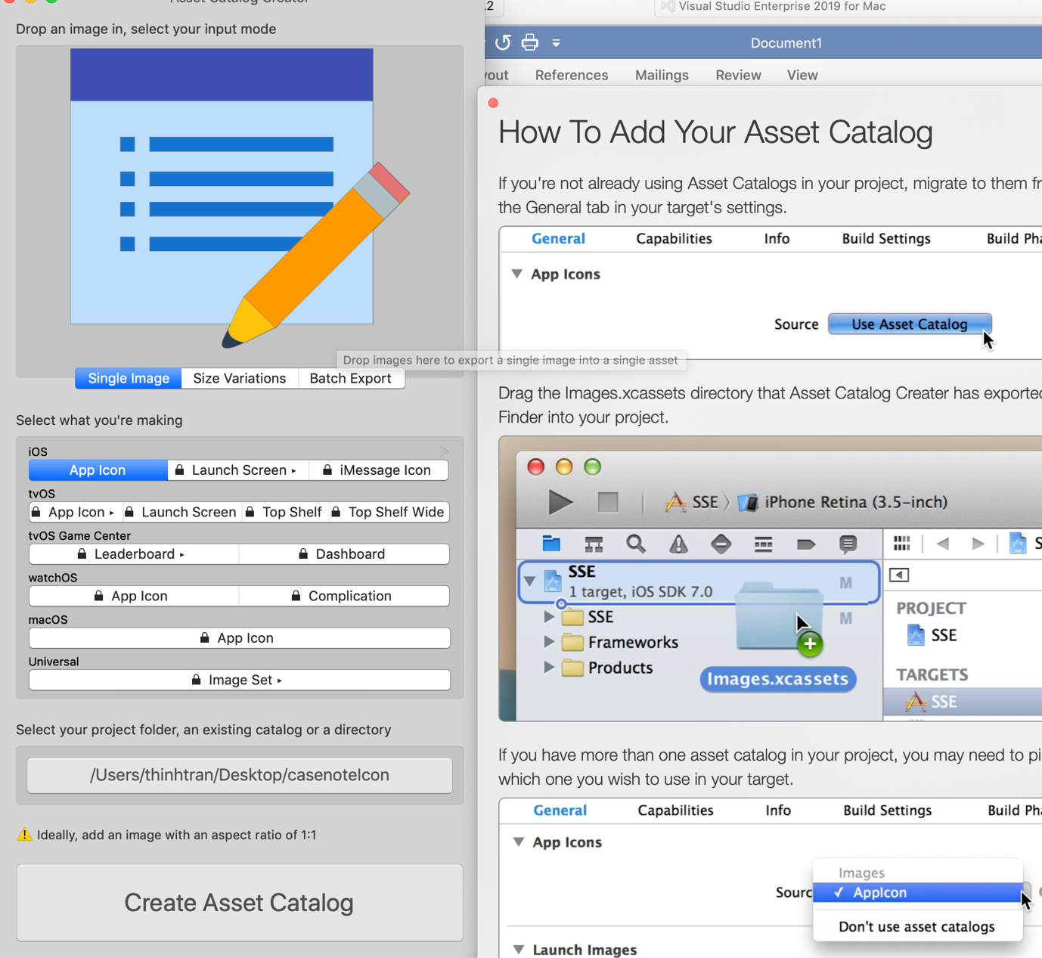

Under .iOS project Select

Assets.xcassets

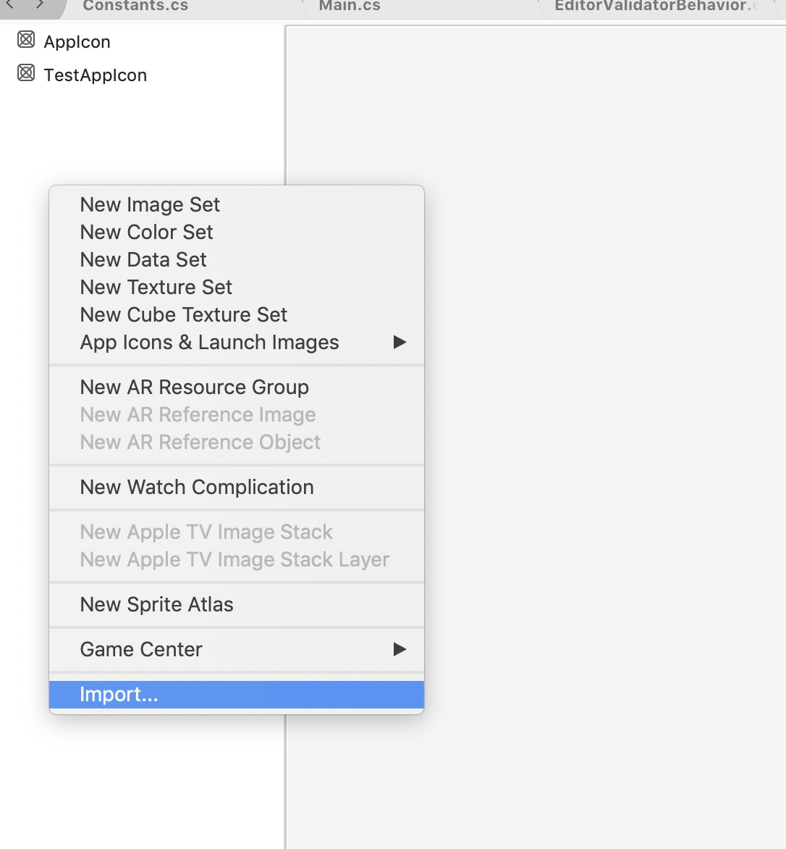

Then select the asset that was generated by the mac app

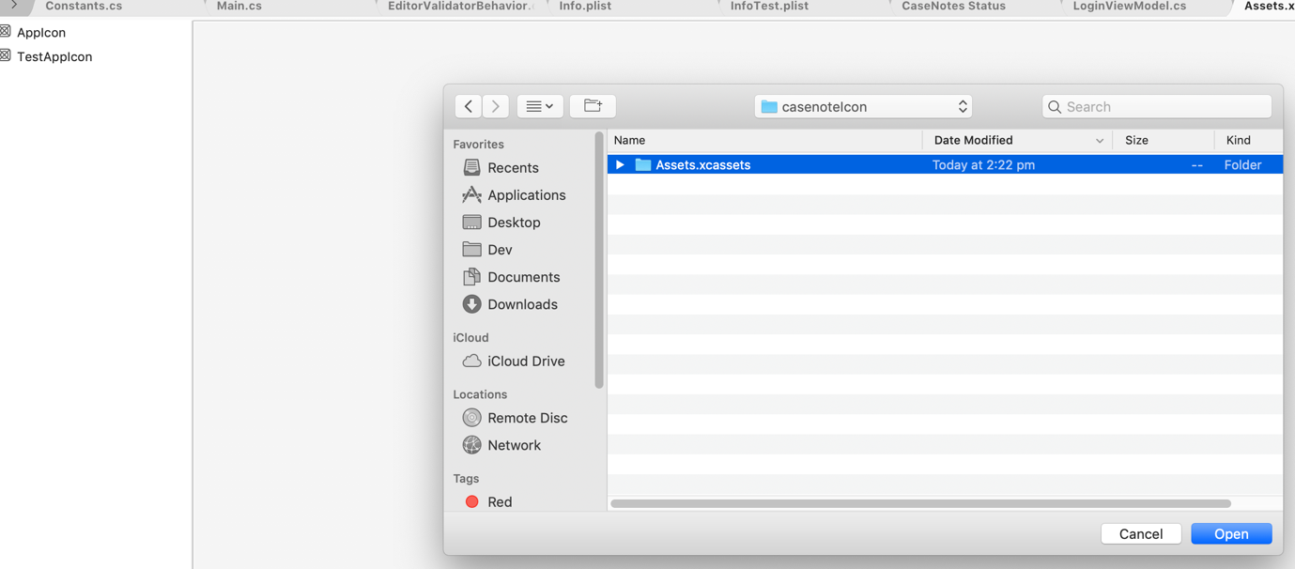

Give it a name, and select in in the Info.plist file